**Careers Content**

Aprilaire

________

**CAREERS PAGE SITEMAP**

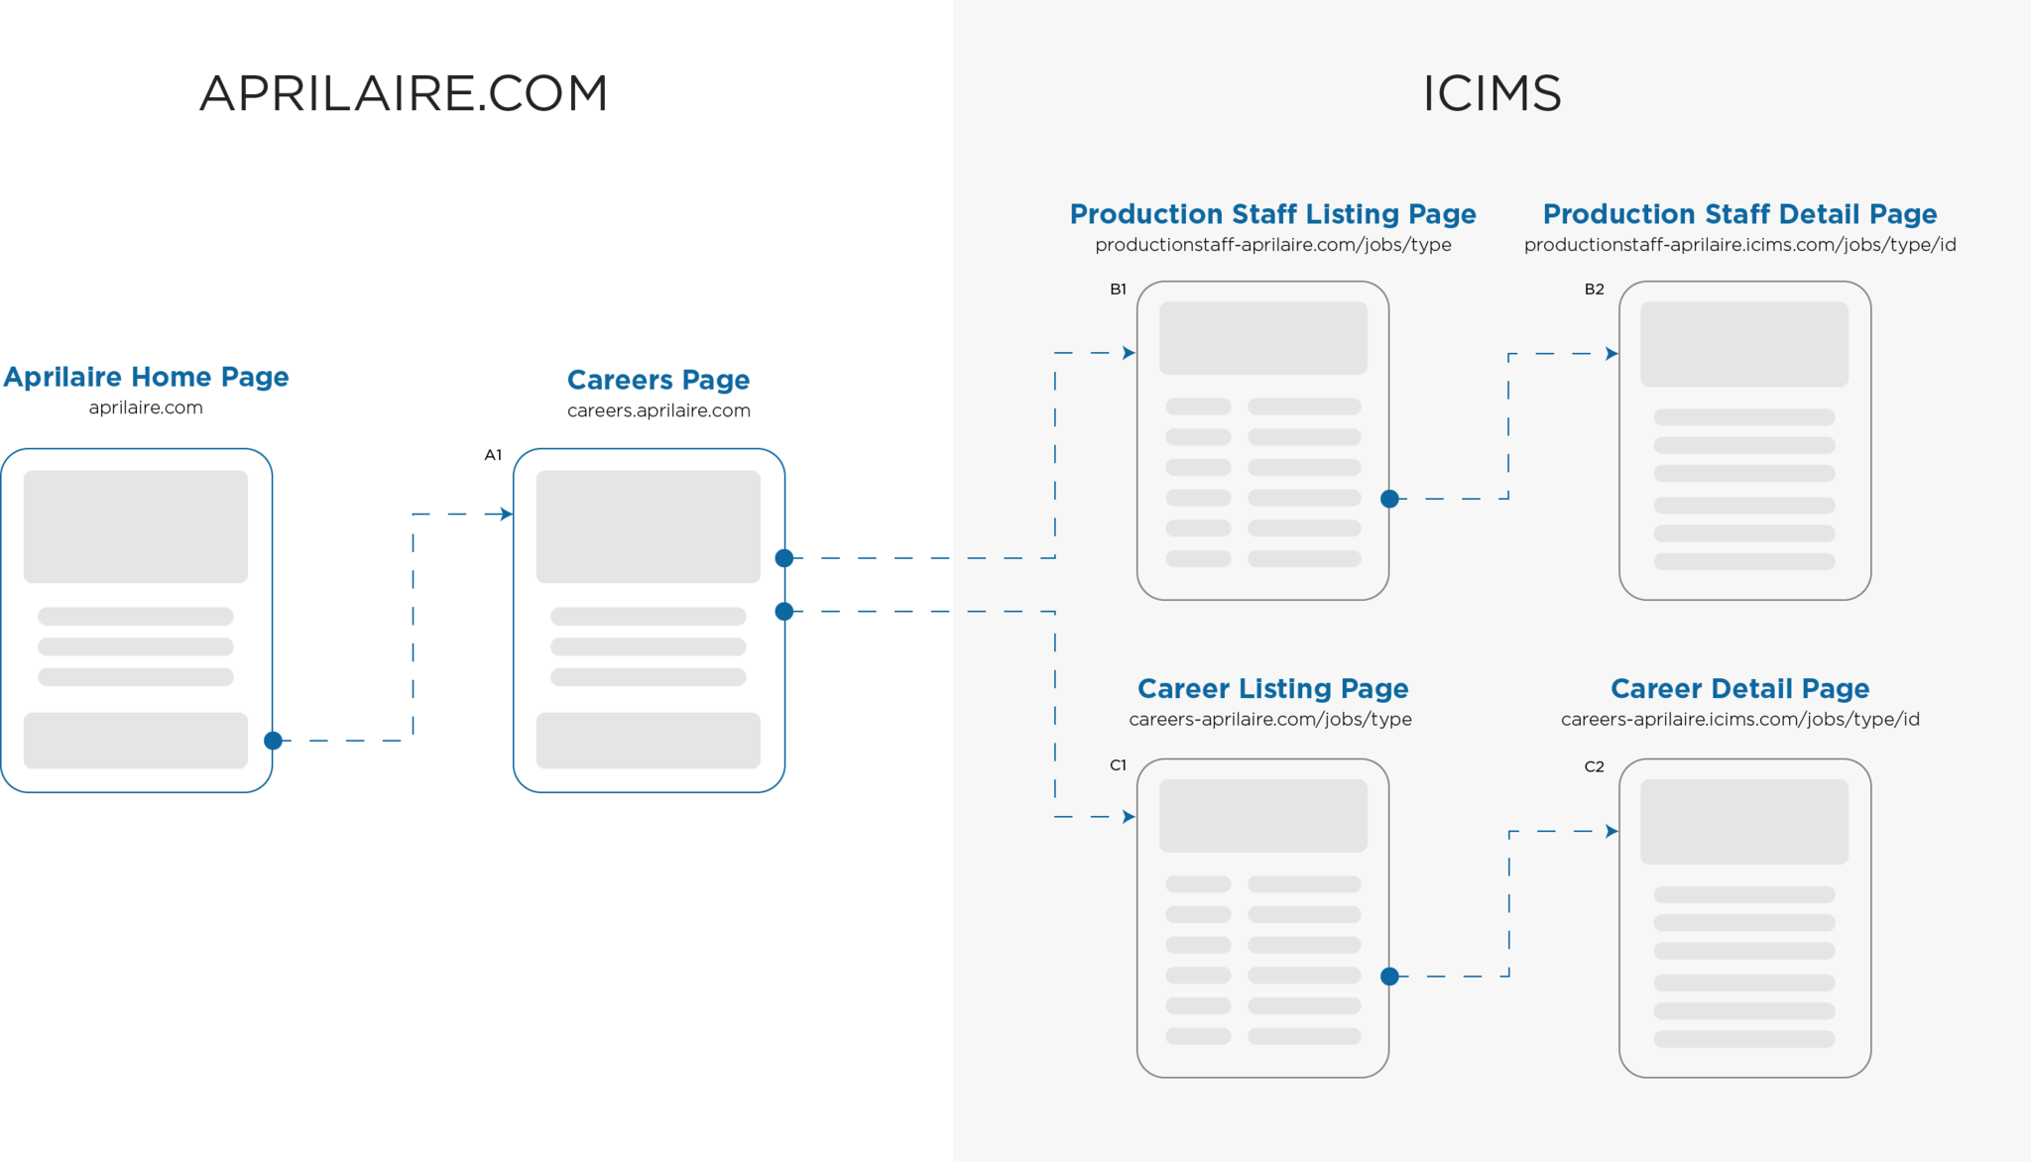

*See Larger Sitemap in Box Folder*

**CAREERS PAGE COPY**

**[Keywords]**

jobs in madison wi 🡪 10K-100K | Low Competition

**[Hero]**

**We’re Making a Difference**

Join a committed team that works together to help families breathe healthy air at home.

🡪 Button: View Corporate Positions

🡪 Button: View Manufacturing Positions

**[Our Brand]**

**Why Work at Aprilaire?**

At Aprilaire, our business has been providing indoor air quality solutions since the inception of Research Products Corporation – our parent company – in 1938.

Our company is privately owned and growing rapidly. We provide great career opportunities for people searching for jobs in Madison, WI – one of *In Business Magazine*’s “Best Places to Work” – and throughout the country.

However, it's our strong culture that drives our growth. Our culture is a reflection of how we work together to provide quality products that help millions of homeowners breathe healthier air.

As a long-standing part of a proud indoor air quality community, we're successful because of the dedication, energy, and professionalism of everyone who works here.

**Aprilaire’s Winning Culture**

We foster values that build and maintain a strong, vibrant workplace.

*Knowing Our Customers (and Our Customers’ Customers)*Providing value to our customers is part of everything we do.

*Innovation*Our employees are a rich source of new ideas that fuel growth.

*Achievement*  
We celebrate our achievements and the achievements of others.

*Passion*We are dedicated to contributing our strengths to a shared purpose.

*Fun*We believe in fun and work/life balance.

*Be Good Neighbors*We are committed to our community and doing the right thing.

**[Benefits & Workplace]**

**Aprilaire Employee Benefits**

Our employees are our most important resource. That’s why we offer competitive compensation and platinum-rated health plans.

*Health and Wellness Benefits*  
Your health and your family’s health are important. We offer:

* Health and Wellness Coaching
* On-Site Health and Wellness Manager
* Wellness Reimbursements
* Community Supported Agriculture
* Personal Well-Being and Mental Health Offerings
* Tobacco Cessation

*Medical Benefits*  
With health care costs on the rise, we do all we can to keep premiums low and quality high. You can choose to enroll in:

* Group Health Cooperative Medical Plan Options
* Delta Dental Insurance
* Delta Vision Insurance

*Insurance and Income Protection Benefits*  
We want you to feel protected. That’s why employees have access to:

* Short- and Long-Term Disability Plans
* Basic Life and AD&D Insurance
* Voluntary Life Insurance
* Long Term Care Insurance
* Business Travel Accident Insurance

*Financial Benefits*  
We want to help all of our employees feel secure in their finances and in their futures. That’s why we offer:

* 401(k) Plan with 50% Match Up to 3% of Annual Compensation
* Profit Sharing
* Flexible Spending Accounts (FSAs)
* College Savings Plans
* Computer Financing Program

*Work-Life Benefits*

We know that a good Work-Life Balance is important to our employees, who are eligible to receive:

* Paid Vacation and Holidays
* Child and Elder Care Services
* Legal Services
* Financial Services
* Counseling Services and Tuition Assistance

**The Perks of Working at Aprilaire**

Need more reasons to look for Aprilaire jobs in Madison, WI and beyond? Look no further!

*Madison, Wisconsin*

An *In Business Magazine* “Best Place to Work”

*Popcorn Tuesdays*

Let’s get popping!

*Gym Partnerships*Take part in on- and off-site fitness classes

*Commuter Biking Initiative*

Indoor parking, showers, and incentives

*Local Organic Farming*  
Food drop offs for healthy diets

*Monthly Catered Lunches*  
Let’s gather, eat and learn together

**A Great Place to Learn, Contribute and Grow**We respect ethical work practices in our work and in our community.

*A Respectful and Ethical Workplace*  
We hold ourselves and each other accountable to do the right thing.

*Community Involvement*  
We believe in being good corporate citizens and supporting our local community.

*Environmental Initiatives*  
We are dedicated to fostering a sustainable future and strive to minimize adverse effects on the environment.

*Promotion from Within and Employee Tenure*  
We provide rewarding careers for our employees, with an average tenure of 10.5 years and opportunities for growth from within.

**[Hiring Process]**

**Our Pillars of Recruitment**

We believe in transparency, communication, fairness and competition.

*Communication*

We respect your time and will maintain communication throughout the application process. We review each resume individually in search of industry experience and fit rather than jargon and buzzwords. Even if you’re not the right person for the role, we’re diligent about communicating that to you in a timely and respectful way.

*Competitive Offerings*

For each role, we offer leading, platinum-rated health benefits and the most competitive compensation packages possible. We also prioritize creating new roles and opportunities that allow us to stay competitive in our industry.

*Seamless Onboarding*

We want you to stay with us and strive to make your onboarding as seamless as possible. Starting with the recruiting phase, each part of our application process will be clearly communicated. After joining us, all new employees participate in traditional onboarding as well as lunches, meetings, and leadership activities.

**[People]**

**People and Experiences**

Meet the friendly faces of Aprilaire.

**Testimonials**

**[View Openings]  
Apply Today**

Join us in having fun, making a difference and helping people breathe healthy air.

🡪 Button: View Corporate Positions

🡪 Button: View Manufacturing Positions

**[Social Feed]**

**Connect with Us!**

*Feed of Aprilaire Instagram*

**[Corporate Page Hero]**

**Corporate**

Further your career with rewarding, hands-on opportunities at Aprilaire!

**[Manufacturing Page Hero]**

**Manufacturing**

Further your career with rewarding, hands-on opportunities at Aprilaire!

**[Job Listing Hero]**

**Join. Have fun. Make a difference. Apply today!**

Page Quote 🡪  
Join a committed team working together to helping families breathe healthy air where they spend their time most – their homes.